Asymmetric DCC correlation: EURUSD and EURGBP
Method 10 / GARCH(1,1) + Cappiello-Engle-Sheppard ADCC / Alpari D1 full available history

Study setup
Logical pair: EURUSD , EURGBP
Broker symbols: EURUSD_i , EURGBP_i
Snapshot: 2026-11-03_majors_alpari_D1
Timeframe: D1
Matched return window: 1999-01-06 to 2026-11-02 (UTC bar dates)
Matched return count n: 7183
Dropped unfinished last bar dated 2026-11-03 UTC after a tick-volume check against the prior complete day.
EURUSD GARCH(1,1): mu=0.000010, omega=0.001157, alpha=0.036734, beta=0.959962
EURGBP GARCH(1,1): mu=-0.000019, omega=0.000646, alpha=0.046281, beta=0.952093
ADCC: a=0.024399, b=0.970579, g=0.000000, a+b+g/2=0.994978
Nested DCC (g=0): a=0.024399, b=0.970579
Negative shock: n = min(z, 0) in broker quote direction (not inverted)
Burn-in ignored in path summaries and chart: first 60 updates
Complete matched rows (Excel): EURUSD-EURGBP_ADCC_D1.xlsx
Complete matched rows (HTML table): EURUSD-EURGBP_ADCC_D1_data.html

Method carried forward
Asymmetric DCC extends Engle DCC with an extra term on joint negative standardised shocks. Each matched daily log return of close, ln(close_t / close_t-1), is first filtered by a constant-mean GARCH(1,1). Then z = residual / sigma and n = min(z, 0). The Cappiello-Engle-Sheppard recursion uses A = (1-a-b) Q_bar - g N_bar with N_bar = mean(n n'). Quotes are not inverted, so a negative shock is a negative log return in the broker quote. Nested symmetric DCC (g = 0) is fit on the same z path for comparison. Constraints: a,b,g >= 0 and a + b + g/2 < 1. Path summaries ignore the first 60 updates. The headline is latest ADCC rho. Pearson r is a side check only. This is not a cause, lead, or trading signal.

Results
Latest ADCC rho: 0.211551
Latest nested DCC rho: 0.211551
Post-burn-in ADCC path (n=7123): mean=0.412072, median=0.422955, min=-0.252551, max=0.802726, std=0.202772
Share of post-burn-in days with |rho| >= 0.4: 53.67%; |rho| >= 0.7: 4.21%
Same-sample Pearson r: 0.439899
ADCC minus r: -0.228348
ADCC minus nested DCC: -0.000000

Conclusion
Over 7183 matched daily log-return rows for EURUSD and EURGBP (broker quote directions unchanged), latest ADCC rho is 0.2116 (positive, weak conditional linear link in this sample) with fitted a=0.0244, b=0.9706, g=0.0000. Nested symmetric DCC latest rho is 0.2116 (ADCC minus DCC = -0.0000). After a 60-day burn-in, path mean is 0.4121 and std is 0.2028. Same-sample Pearson r is 0.4399 (ADCC minus r = -0.2283). This does not establish cause, lead-lag, or a lasting trading rule.

Charts
Daily closes

Daily log returns
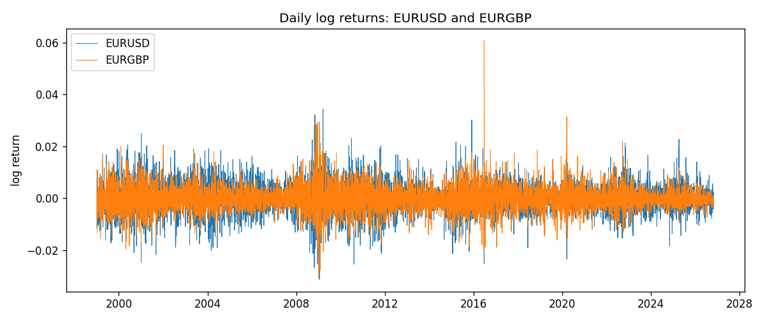
ADCC rho path with nested DCC and Pearson r
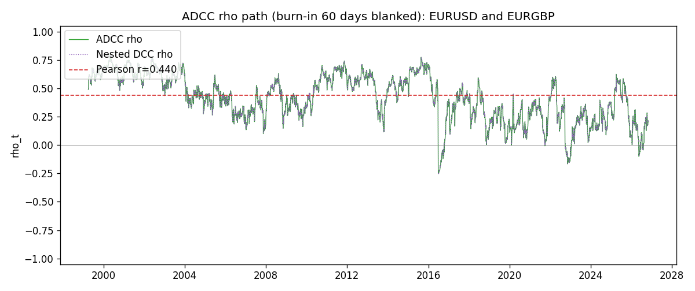

Data report
Every matched row that entered the ADCC recursion is stored in the sibling Excel workbook named EURUSD-EURGBP_ADCC_D1.xlsx. Embedding all rows as a Word table is impractical at this length; the Word file holds the column list, column summaries, and the first and last 15 matched rows.
Columns: time, EURUSD_open, EURGBP_open, EURUSD_high, EURGBP_high, EURUSD_low, EURGBP_low, EURUSD_close, EURGBP_close, EURUSD_tick_volume, EURGBP_tick_volume, EURUSD_spread, EURGBP_spread, EURUSD_real_volume, EURGBP_real_volume, EURUSD_log_return, EURGBP_log_return, EURUSD_sigma, EURGBP_sigma, EURUSD_z, EURGBP_z, EURUSD_n, EURGBP_n, q11, q22, q12, rho_adcc, rho_dcc
Column summaries (matched calculation rows)
column | count | mean | std | min | 25% | 50% | 75% | max
EURUSD_open | 7183 | 1.1815763 | 0.15079461 | 0.8272 | 1.08621 | 1.16623 | 1.29409 | 1.5995
EURGBP_open | 7183 | 0.78698868 | 0.09663692 | 0.5734 | 0.6877 | 0.83389 | 0.86522 | 0.9769
EURUSD_high | 7183 | 1.1867072 | 0.15139096 | 0.8326 | 1.09029 | 1.17134 | 1.29941 | 1.6038
EURGBP_high | 7183 | 0.79006638 | 0.09701205 | 0.5789 | 0.6897 | 0.8369 | 0.8681 | 0.9799
EURUSD_low | 7183 | 1.1765677 | 0.15011491 | 0.8227 | 1.08209 | 1.16259 | 1.288515 | 1.5865
EURGBP_low | 7183 | 0.78428899 | 0.09645396 | 0.5682 | 0.6857 | 0.83166 | 0.86287 | 0.9661
EURUSD_close | 7183 | 1.1816163 | 0.15076829 | 0.8267 | 1.086135 | 1.16619 | 1.2941 | 1.5997
EURGBP_close | 7183 | 0.78703222 | 0.09663758 | 0.5735 | 0.6878 | 0.83395 | 0.86536 | 0.977
EURUSD_tick_volume | 7183 | 103246.15 | 173560.03 | 218 | 9420.5 | 52790 | 99596.5 | 1471626
EURGBP_tick_volume | 7183 | 87133.93 | 145499.42 | 154 | 6594.5 | 44358 | 81413 | 1424684
EURUSD_spread | 7183 | 19.326744 | 16.542159 | 0 | 8 | 12 | 20 | 50
EURGBP_spread | 7183 | 21.324655 | 19.119277 | 0 | 4 | 13 | 40 | 50
EURUSD_real_volume | 7183 | 4.0347326e+10 | 1.669497e+11 | 0 | 0 | 0 | 0 | 3.6149665e+12
EURGBP_real_volume | 7183 | 2.7872287e+10 | 1.3521454e+11 | 0 | 0 | 0 | 0 | 3.5726265e+12
EURUSD_log_return | 7183 | -5.81e-06 | 0.0057996 | -0.03123819 | -0.00324487 | 0 | 0.00325442 | 0.03433183
EURGBP_log_return | 7183 | 2.227e-05 | 0.00487305 | -0.03067367 | -0.00262314 | -9.879e-05 | 0.00256076 | 0.06075387
EURUSD_sigma | 7183 | 0.00556528 | 0.00169949 | 0.00258164 | 0.00432332 | 0.00537951 | 0.00649335 | 0.01458918
EURGBP_sigma | 7183 | 0.00463586 | 0.00169624 | 0.00185518 | 0.0034303 | 0.00442164 | 0.00553658 | 0.01544814
EURUSD_z | 7183 | -0.00314262 | 0.99999402 | -5.7777211 | -0.61987443 | -0.0016191 | 0.60928637 | 5.2067391
EURGBP_z | 7183 | 0.00754532 | 1.0000693 | -3.790833 | -0.62212021 | -0.02001761 | 0.59665276 | 8.4830274
EURUSD_n | 7183 | -0.3869592 | 0.59319768 | -5.7777211 | -0.61987443 | -0.0016191 | 0 | 0
EURGBP_n | 7183 | -0.37964834 | 0.57010875 | -3.790833 | -0.62212021 | -0.02001761 | 0 | 0
q11 | 7183 | 1.0006792 | 0.17505844 | 0.59344324 | 0.88129082 | 0.9852727 | 1.0973632 | 2.0163226
q22 | 7183 | 1.0013183 | 0.18472796 | 0.63931983 | 0.87858851 | 0.97559854 | 1.0935268 | 2.9632219
q12 | 7183 | 0.41745405 | 0.22993078 | -0.54485444 | 0.24993557 | 0.40925919 | 0.5901299 | 1.0574876
rho_adcc | 7183 | 0.41264739 | 0.20205573 | -0.2525512 | 0.26742395 | 0.4246385 | 0.57913124 | 0.80272576
rho_dcc | 7183 | 0.41264739 | 0.20205572 | -0.25255187 | 0.26742377 | 0.42463852 | 0.57913125 | 0.80272582
First 15 matched rows (selected columns)
time | EURUSD_log_return | EURGBP_log_return | EURUSD_z | EURGBP_z | EURUSD_n | EURGBP_n | q11 | q22 | q12 | rho_adcc | rho_dcc
1999-01-06 | -0.011547966 | -0.013303338 | -1.7437794 | -2.3700286 | -1.7437794 | -2.3700286 | 1 | 1 | 0.41634172 | 0.41634172 | 0.41634172
1999-01-07 | 0.0076280636 | 0.011051402 | 1.1089256 | 1.7923199 | 0 | 0 | 1.0497918 | 1.1126492 | 0.50701825 | 0.46912964 | 0.46912971
1999-01-08 | -0.010902799 | -0.004943862 | -1.5824991 | -0.7594889 | -1.5824991 | -0.7594889 | 1.0539317 | 1.1633146 | 0.54268572 | 0.49011001 | 0.49011011
1999-01-11 | -0.007103287 | -0.0012752393 | -1.0045589 | -0.19571737 | -1.0045589 | -0.19571737 | 1.0890478 | 1.1481849 | 0.55813486 | 0.4991255 | 0.49912561
1999-01-12 | 0.0045103728 | 0.0033970309 | 0.63578863 | 0.54421143 | 0 | 0 | 1.086651 | 1.1203612 | 0.54860204 | 0.49720257 | 0.49720267
1999-01-13 | 0.010845346 | 0.00042381861 | 1.5485584 | 0.071660295 | 0 | 0 | 1.0695656 | 1.0996475 | 0.54299468 | 0.50068562 | 0.50068573
1999-01-14 | 0 | -0.0019793588 | -0.0013806492 | -0.32519552 | -0.0013806492 | -0.32519552 | 1.1016289 | 1.0724425 | 0.53181781 | 0.48928083 | 0.48928092
1999-01-15 | -0.010153245 | -0.0076715819 | -1.4447526 | -1.2962459 | -1.4447526 | -1.2962459 | 1.0742404 | 1.0484928 | 0.51827322 | 0.48834338 | 0.48834346
1999-01-18 | 0.0036256946 | 0.00071280921 | 0.50427383 | 0.12195739 | 0 | 0 | 1.098585 | 1.0636633 | 0.55080874 | 0.50954423 | 0.50954434
1999-01-19 | -0.00017235436 | -0.0014261269 | -0.025787545 | -0.24023714 | -0.025787545 | -0.24023714 | 1.0774904 | 1.0377546 | 0.53819497 | 0.50896229 | 0.5089624
1999-01-20 | -0.0031939256 | 0.0019960086 | -0.46210715 | 0.35153957 | -0.46210715 | 0 | 1.0508282 | 1.0136534 | 0.52460295 | 0.50830004 | 0.50830014
1999-01-21 | 0.0030215416 | -0.00071240297 | 0.44100471 | -0.12358692 | 0 | -0.12358692 | 1.0301443 | 0.99186828 | 0.50729614 | 0.5018634 | 0.50186349
1999-01-22 | -0.0012075213 | -0.0017118406 | -0.18104561 | -0.30865293 | -0.18104561 | -0.30865293 | 1.009604 | 0.96808159 | 0.49313226 | 0.49880626 | 0.49880635
1999-01-25 | -0.0030251979 | -0.0054402425 | -0.45977261 | -1.0093565 | -0.45977261 | -1.0093565 | 0.9857226 | 0.94694644 | 0.48207827 | 0.49897351 | 0.4989736
1999-01-26 | 0.00086527651 | -0.00057438255 | 0.13153933 | -0.10340199 | 0 | -0.10340199 | 0.96690171 | 0.94896603 | 0.48130886 | 0.50246679 | 0.50246688
Last 15 matched rows (selected columns)
time | EURUSD_log_return | EURGBP_log_return | EURUSD_z | EURGBP_z | EURUSD_n | EURGBP_n | q11 | q22 | q12 | rho_adcc | rho_dcc
2026-10-13 | 0.0037402957 | 0.00020130374 | 1.0796817 | 0.10923047 | 0 | 0 | 0.91380811 | 0.74423907 | 0.23419989 | 0.28398994 | 0.28399026
2026-10-14 | -0.0037582255 | 0.0011241873 | -1.0838624 | 0.57687147 | -1.0838624 | 0 | 0.92038709 | 0.72765628 | 0.23227793 | 0.28383081 | 0.28383112
2026-10-15 | 0.0056053107 | -0.00087557391 | 1.5993467 | -0.43614727 | 0 | -0.43614727 | 0.92699322 | 0.71938964 | 0.21227988 | 0.25994919 | 0.25994946
2026-10-16 | 0.0017724895 | -0.0020380844 | 0.48856012 | -1.0394533 | 0 | -1.0394533 | 0.96715192 | 0.70788804 | 0.19110615 | 0.23096438 | 0.2309646
2026-10-19 | -0.0025394633 | -0.00056950988 | -0.71468393 | -0.28089133 | -0.71468393 | -0.28089133 | 0.94954347 | 0.7184454 | 0.17518414 | 0.21209991 | 0.21210008
2026-10-20 | 0.0023881672 | -0.0035906254 | 0.67081707 | -1.8466642 | 0 | -1.8466642 | 0.9390915 | 0.70425542 | 0.17701902 | 0.21767115 | 0.21767134
2026-10-21 | -0.00032046717 | -0.00140647 | -0.093857748 | -0.67582257 | -0.093857748 | -0.67582257 | 0.92746414 | 0.7717612 | 0.14367761 | 0.16982399 | 0.16982409
2026-10-22 | -0.0015949606 | -0.0018743924 | -0.46302838 | -0.90888703 | -0.46302838 | -0.90888703 | 0.90541455 | 0.7652213 | 0.14308908 | 0.17190529 | 0.17190539
2026-10-23 | -0.001338521 | 0.00082421033 | -0.39349964 | 0.41154287 | -0.39349964 | 0 | 0.88902968 | 0.76788517 | 0.15123816 | 0.18304384 | 0.18304396
2026-10-26 | -0.0022706559 | 0.00013133309 | -0.67382165 | 0.074113103 | -0.67382165 | 0 | 0.87167386 | 0.75444791 | 0.14492841 | 0.17871536 | 0.17871548
2026-10-27 | -0.004152342 | -0.0019957343 | -1.238026 | -0.99358949 | -1.238026 | -0.99358949 | 0.86212856 | 0.73740768 | 0.14153702 | 0.17751301 | 0.17751313
2026-10-28 | 0.0022262927 | 0.00066967224 | 0.65068252 | 0.34344041 | 0 | 0 | 0.87918218 | 0.74482155 | 0.16947629 | 0.20943218 | 0.20943234
2026-10-29 | 0.0022571351 | -0.0011722209 | 0.66457723 | -0.5834462 | 0 | -0.5834462 | 0.86866821 | 0.73080836 | 0.17203349 | 0.21591573 | 0.2159159
2026-10-30 | -0.0011458446 | -0.0024205543 | -0.34415474 | -1.2243719 | -0.34415474 | -1.2243719 | 0.85890946 | 0.72263511 | 0.15960265 | 0.20258481 | 0.20258496
2026-11-02 | 0.002120569 | 0.00089940465 | 0.63665511 | 0.45920865 | 0 | 0 | 0.8415517 | 0.74297243 | 0.16727889 | 0.21155066 | 0.21155082

